____________________________________________
COVID-19 pandemic and its impacts on regional economy in Indonesia:
A spatial econometric approach

Harry Agintaª · Ragdad Cani Miranti^{b} · Carlos Mendez^{c}

Abstract
The purpose of this study is twofold; first, to reveal spatial pattern of the coronavirus (COVID-19) infection across provinces in Indonesia and second, to investigate the impacts of the virus outbreak on regional economic growth. For these purposes, we define a spatial connectivity structure across the provinces of Indonesia. Applying spatial exploratory data technique on published data, we show how spatial connectivity alters COVID-19 spread over time from the spatial perspective. While results from appropriate spatial econometric model suggest the significance of spatial spillovers of “shocks” on provincial economic growth in the period of pandemic as opposed to non-significant spatial effect prior the pandemic.

Keywords COVID-19 · pandemic · regional · Indonesia
JEL Classifications C21 · O47 · R10 · R11

____________________________
ª Graduate School of International Development, Nagoya University, JAPAN.
E-mail: aginta.harry@c.mbox.nagoya-u.ac.jp
^{b} Graduate School of International Development, Nagoya University, JAPAN.
E-mail: miranti.ragdad.cani@g.mbox.nagoya-u.ac.jp
^{c} Graduate School of International Development, Nagoya University, JAPAN.
E-mail: carlos@gsid.nagoya-u.ac.jp

Introduction

Firstly detected in Wuhan, China in December 2019, the outbreak of novel coronavirus COVID-19 has attracted worldwide attention. According to World Health Organization (WHO), the first detected case outside of China was reported in Thailand on 13 January 2020 (WHO, 2020a). Thereafter, the number of infected people around the world started to show an explosive trend. Referring to the Situation Report of WHO, by the end of January 2020, the disease had infected 9,826 people globally, where 106 people were situated in 19 countries outside China (WHO, 2020b). By the end of June 2020, the same report had announced more than 10 million confirmed cases and more than 500,000 deaths (WHO, 2020c).
To limit the massive spread of the virus, more than 100 countries worldwide had implemented lockdown by the end of March 2020, either a full or partial lockdown (BBC, 2020). As lockdown policy massively instituted around the world, people’s activities had been greatly reduced, including economic and business. Several ideas explain how the pandemic may affect economic activities. A report from Asian Development Bank (ADB, 2020) mentions that COVID-19 outbreak will negatively affect economic activity via multiple channels: a sharp decline in domestic consumption, and possibly investment if views on future business activity is affected; shrinking in tourism and business travel; cross-sector and cross-country spillovers from slowing demand through trade and production linkages; supply-side disruptions to production and trade; and effects on health such as increased disease and mortality as well as shifts in health care spending.
Hausmann (2020) argues the economic impact of COVID-19 is mainly in the forms of negative supply shock stemming from reduction in production capacity. When workers are infected, firms have to limit the contact between workers and if needed, stop the production temporarily. Inoue and Todo (2020) estimate that shutting down firms in Tokyo would result in an 86% reduction in output throughout Japan within one month. If the situation lasts for more than what expected, the supply shock would most likely lead to a demand shock (del Rio-Chanona et al., 2020; Guerrieri et al., 2020). In its World Economic Outlook (WEO) Update, June 2020, International Monetary Fund (IMF, 2020) mentions that global growth in 2020 is projected at –4.9%, 1.9 percentage points below its April forecast, indicating that the pandemic has had a more negative impact on activity in the first half of 2020 than anticipated.
Reviewer 1 (R1): The authors may also discuss the demand shock due to limitation of people movement (physical distancing
In summary, the economic downturn that is happening in most of countries will affect the performance of global economy via spillover effects in several channels, such as trade, investment and financial market channels. The unprecedented health crisis certainly leads to global recession.
In Indonesia, the first COVID-19 infection was announced in early March 2020. As of 1 July 2020, the number of confirmed infected people in the country had reached close to 57,770, with 2,934 deaths (WHO 2020d). Worse still, it is predicted that total confirmed deaths in Indonesia by 1 November 2020 would reach more than 12,800 (covid19-projections.com 2020). Like elsewhere in the world, the economic impact of COVID-19 in Indonesia is huge. The government’s latest 2020 Gross Domestic Product (GDP) forecast is a range between 1.1% contraction to 0.2% growth, down from 2019’s 5% expansion, due to the fallout of the coronavirus pandemic (source?). A double hit scenario proposed by the OECD (OECD 2020) projects that the Indonesian economic growth rate could contract to –3.8%.

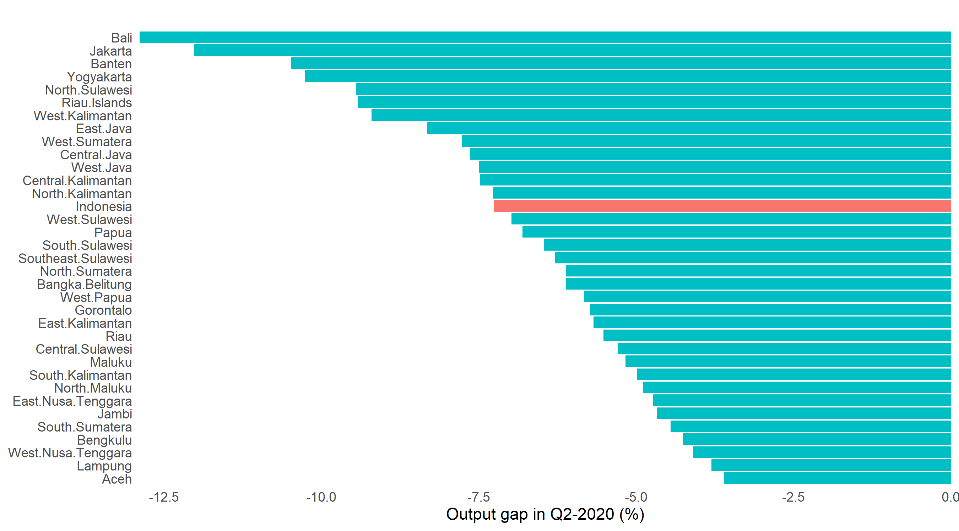
Figure 1. GDP loss in Q2-2020 measured by output gap

The slowing economic activities in Indonesia has been reflected in the report of the 2020 first semester economic performance. Figure 1 shows the impact of COVID-19 outbreak on national and regional GDP in Indonesia during Q2-2020, measured in output gap. At the national level, the pandemic had trimmed economic capacity by around 7.5% (R1: put citation or reference over here). In other words, under the implementation of large-scale social restrictions policy (Pembatasan Sosial Berskala Besar - PSBB) in many regions, the nation’s economy worked around 92.5% of its capacity. At the provincial level, all provinces exhibited negative output gap, reflecting the depletion in economic capacity. Tourism and services driven regions like Bali, Jakarta and Banten are provinces with the highest negative output gap (R1: adding citation).
Just like cross-country economic spillover that is inevitable, within-country spillovers is also expected. Even more, since regions within a country has more similarities compared to a cross-country situation, the spillover effect is expected to be more prevalent.
(But you have mentioned why it is important to analyze the impacts of the spatial growth across provinces in Indonesia)
Therefore, this paper attempts to measure how the pandemic affects the spatial growth across provinces in Indonesia. In the absence of adequate number of similar studies available so far, the facts and results revealed in this paper would help to bring new insights in understanding how the transmission of COVID-19 infection is linked to the spatial connectivity, and how Indonesian regional economy is affected by the pandemic.
Before estimating the growth spillover, in the first part of the paper we conduct exploratory spatial data analysis (ESDA) for the COVID-19 infection cases. Our exploration indicates the link between spatial connectivity and the spread of the virus. This is particularly seen in Java region, mainly between Jakarta, West Java and Central Java, the three neighboring provinces. Regarding to the spatial spillover of economic growth impacts of COVID-19, the results from spatial econometric models show that the provincial growth in the pandemic period is affected by the spillover of shocks in the surrounding regions.
The rest of this paper is organized as follows. The second section exposes some stylized facts related to the dynamics on COVID-19 cases in Indonesian regions and the latest figure of regional economic growth. In Section 3 we discuss data and methodology. Section 4 presents the results and discussion, and finally Section 5 concludes the paper.

COVID-19 PANDEMIC IN INDONESIA

Before formally analyzing the impacts of COVID-19 cases on regional economic growth, it is necessary to document some important facts that are useful to understand the context of the analysis. In Figure 2, we provide the charts of selected variables related to COVID-19 cases and the economic impacts across provinces. Panel (a) plots the change in number of COVID-19 cumulative cases (per 100,000 population) from March to June 2020. The highest increase of number of cases is recorded in Jakarta, the capital of Indonesia (100.3), followed by South Kalimantan (72.9), and North Maluku (56.85), while Aceh province records the lowest increase in number of cases per 100,000 population (R1: sources of data).

In terms of the impact of COVID-19 on economic growth, most of provinces (32 out of 34) recorded negative growth in Q2-2020, where provinces in Java-Bali region are the worst performers (panel (b)). The economic growth of Bali, Jakarta, Banten provinces are -10.98%, -8.22%, and -7.4% (year-on-year) respectively. On the other hand, two easternmost provinces, West Papua and Papua, were able to maintain positive economic growth of 0.53% and 4.52% respectively. We also utilize the COVID-19 Community Mobility Index from Google to capture the effects of pandemic on people mobility. From panel (c), it can be seen that Bali, Maluku and Jakarta are the provinces where mobility reduced the most relative to the baseline. Lastly, we also document the number of people who lose their jobs as the impacts of COVID-19 pandemic, plotted in panel (d). Similar to the impacts on economic growth, provinces in the Java region report the highest number of people who had lost their jobs due to pandemic. West Java province suffers the most with around 340,000 people reporting lost their jobs from March to June 2020. Next, Jakarta, Central Java and East Java are the other provinces that record high numbers of jobs losses during the same period (R1: sources of data).

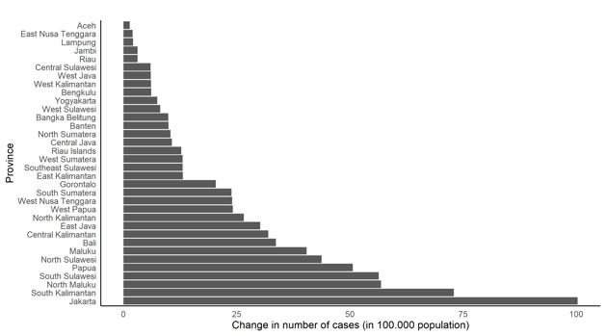  (a) Change in number of cases | 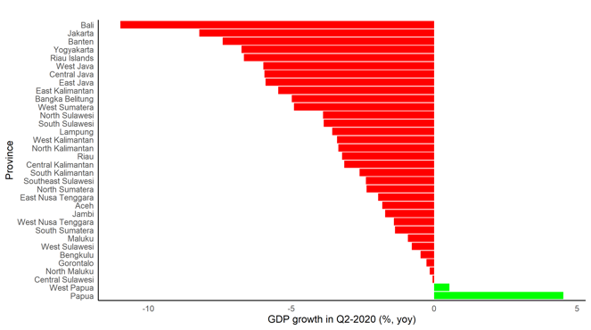  (b) GDP growth in Q2-2020
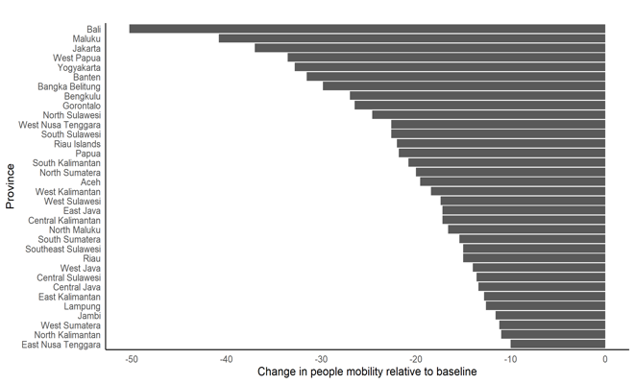  (c) Change in people’s mobility | 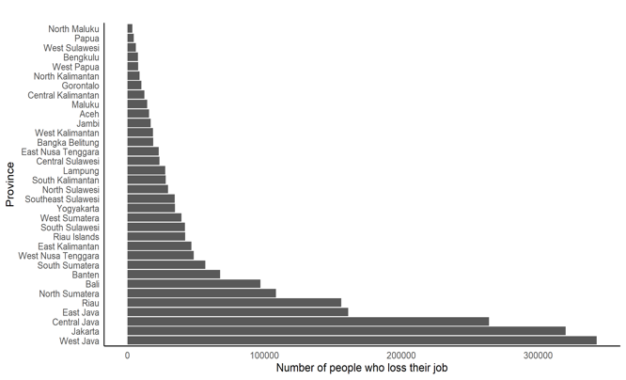  (d) Number of people who lose jobs
(R1: source of data?)
Figure 2. COVID-19 cases and its impacts on main economic variables

Plots in Figure 2 may stimulate a critical question; how do those variables are correlated one each other? Answering this question is important because it will help us to understand how economic activities are affected by the intensity of the spread of the virus. To answer the question, we implement correlation test between these selected variables and plot the result in Figure 3.
People’s mobility is significantly having negative correlation with the change in number of COVID-19 cases and R1: Transportation, Accommodation and Services (TAS) share in GDP. This means that mobility decreases at the larger rate in provinces with higher COVID-19 cases and TAS share. Meanwhile, GDP growth is more connected to number of jobs lost and TAS share in GDP. Lastly, in addition to people’s mobility, change in number of COVID-19 cases is also significantly correlated with TAS share in GDP. From the correlation test, it can be asserted that the link between number of COVID-19 cases and economic growth is not crystal clear, given that fact that the correlation between the two is not significant. Thus, the connection is rather vague and need further exploration. However, the plot underlines the importance of economic structure, where it is significantly correlated both with GDP growth and number of cases. Since the number of infected people is higher in provinces with higher TAS share in GDP, local government implemented large-scale social restrictions (PSBB) policy to minimize contacts among people, such as schools’ closure, work-from-home, restrictions on religious congregations and even closing of houses of worship. As the results, people’s mobility decreased, reflected in its negative correlation with change in number of cases. Eventually, the reduction in people’s mobility decelerates economic activities, albeit the correlation between people’s mobility and GDP growth is not significant.
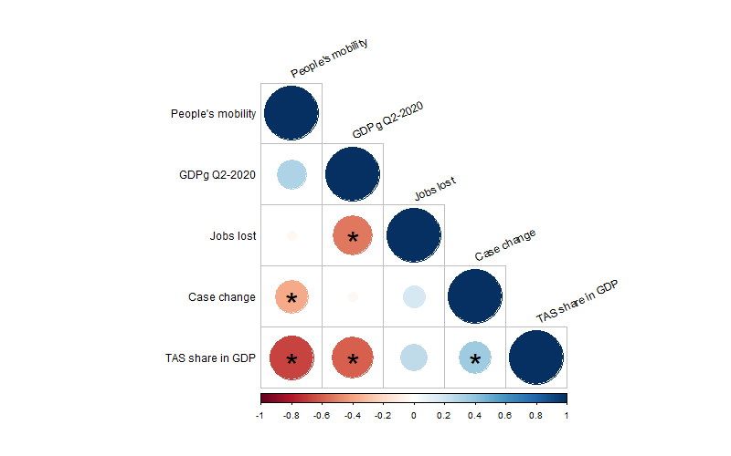
Figure 3. Correlation between selected variables. Significant correlation at 5% is marked with star.
(Content of this section is not that clear at the moment. Probably best to describe (historically) the spread of the pandemic across provinces in Indonesia. So a snap as this is not useful.)

Check and review also several regulation re COVID and people movement:
https://covid19.go.id/p/regulasi

LITERATURE REVIEW
R1: The literature discussing spillover between provinces is not available. In addition, the discussion on the economics shock on regional growth is also not available.

Note that there are literature on spatial regional correlation in Indonesia before. Several are in previous IRSA Book:

https://www.dropbox.com/s/g3hg254dyr1gujt/Chapter_13_2011.pdf?dl=0
https://www.dropbox.com/s/2e588dmxompb0ny/Chapter_5_2009.pdf?dl=0
Or from other resources. For example:
https://www.anzrsai.org/assets/Uploads/PublicationChapter/Vidyattama-2014-2.pdf
https://www.tandfonline.com/doi/full/10.1080/19475683.2013.806353
https://link.springer.com/article/10.1007/s10109-005-0016-3

Data and Methodology

We use data available in https:// kawalCOVID19.id. This data is used to evaluate the spatial dependence of COVID-19 infection cases across Indonesian provinces. The original data contains daily cumulative cases in 34 provinces. We transformed the daily data into a ratio of monthly cumulative case per 100.000 population and used it as the final data.
We used quarterly provincial real GDP data published by Indonesian Central Statistics Bureau to capture real economic variable. The final form of GDP data used is the annual GDP growth rate (yoy, %). We utilize this dataset to estimate the spatial dependence of economic impacts of COVID-19 across provinces.

(put Table showing descriptive statistics of variables in your data set over here).

To carry out a spatial analysis, we first define a spatial connectivity structure across the provinces of Indonesia. In the literature, there are multiple criteria to define that structure. The most popular are spatial contiguity, spatial distance, and k-nearest neighbors. In this paper, we implement a generalized version of spatial contiguity based on the estimation of Thiessen polygons. The estimation of Thiessen polygons allows us to define a spatial connectivity structure based on individual areas of influence around geographical locations. R1: What kind of data employed to capture the connectivity across regions, please explain.
Figure 4 shows the Thiessen polygons that are associated with the spatial configuration of the provinces of Indonesia, which is represented by both the boundaries and centroid points of each province. Based on the location of the centroid point of each province, a Thiessen polygon indicates a potential area of influence between provinces. Specifically, the boundaries of a Thiessen polygon define the area that is closest to each centroid point relative to all other points. Geometrically, they are defined by the perpendicular bisectors of the lines between all points.
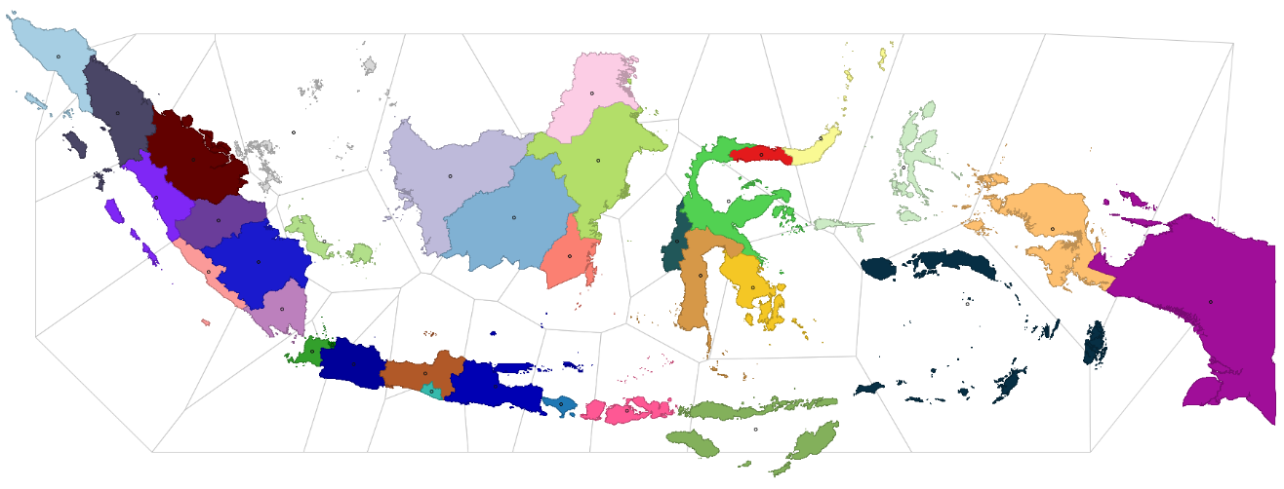
Figure 4. Indonesian provinces, centroids, and Thiessen polygons

After estimating the Thiessen polygons, a spatial connectivity structure (network of connections) is defined based on the contiguity of the of the polygons (Figure 5). Specifically, two polygons (or provinces) are neighbors when they share a common border or an edge. To facilitate visual interpretation, Figure 6 shows the overlap between the estimated connectivity structure and the provincial map of Indonesia.
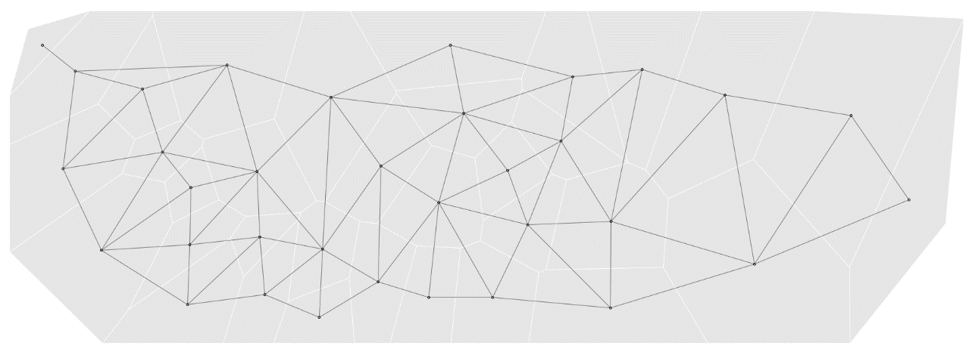
Figure 5. Centroids, Thiessen polygons, and spatial connectivity structure

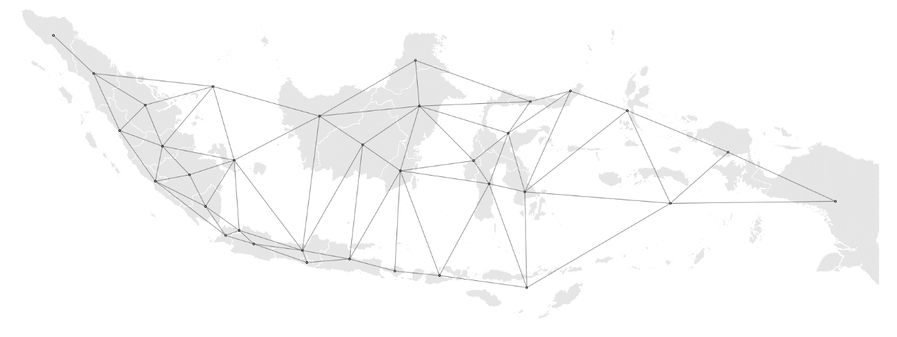
Figure 6. Spatial connectivity structure of the provinces of Indonesia

In the context of the previously estimated connectivity structure, an exploratory spatial data analysis provides a first evaluation of the nature of spatial dependence that is observed in the data. An analysis of spatial dependence combines the notion of attribute similarity with locational similarity. That is, measuring to what extend the neighbors of a region show similar or dissimilar patterns in the attribute being studied.
Anselin (1995) proposes way to visualize the strength and type of local spatial dependence. He uses a scatter plot to study the relationship between an attribute of a region (x) and the weighted average of its neighbors (Wx). The neighbors of every region are identified based on the previously estimated connectivity structure, which is operationalized as a weights matrix (W). The quadrants of the scatter plot classify the regions as hot spots (relatively high values), cold spots (relatively low values), and spatial outliers (high values surrounded by low values and vice-versa).
A local indicator of spatial association (LISA), I_{i} , is computed for each region as follows:
$$I_{i}=\frac{\left(x_{i}-μ\right)}{∑{\left(x_{i}-μ\right)}^{2}}\sum_{j}{ }w_{ij}⋅\left(x_{j}-μ\right)$$ | (1)
where $w_{ij}$ is a spatial weight that is derived from the spatial structure W, $x_{i}$ is the variable under study measured in region i, $x_{j}$ is the same variable measured in region j, and $μ$ is the average of x. Following Anselin et al. (2007), statistical inference is based on a conditional permutation approach.

In this present paper, we examine the regional growth impacts of COVID-19 pandemic by applying spatial regression framework. Basically, spatial analysis is about accounting for spillover effects derived from spatial dependence between regions. Spatial autoregressive models broaden the ordinary linear regression through permitting dependent variables in one area to be affected by dependent variables in neighboring areas, covariates from neighboring areas, and errors from neighboring areas. Anselin (1988) has firstly introduced two common models to recognize spatial dependence through spatial autoregressive models, which are Spatial Lag Model (SLM) and Spatial Error Model (SEM). It commonly consists of spatial lag model and the spatial error model. Fingleton and Lopez-Bazo ´ (2006) also confirms that spatial dependence among growth processes of sub-national level may be caused by two types of features. The first feature is correlated with random shocks, symbolized by spatial error models, coming from neighboring regions and another one is correlated with the growth rates of neighboring regions, symbolized by spatial lag models.
Taking standard linear regression as the starting point, we define the formula OLS linear regression as follows:
$$log⁡\left(\frac{g_{it}}{g_{i0}}\right)=γ+βlog⁡g_{i0}+ε_{i}$$ | (2)
where $g_{i0}$ is GDP of province i at the initial period (2019:Q1), $\left(\frac{g_{it}}{g_{i0}}\right)$ is growth rate of province i, γ is a constant term, and $ε_{i}$ is a random error.
The seminal works of Rey and Montouri (1999) and Fingleton (1999) extend the model of Equation 2 to involve the role of spatial dependence across regions. The purpose of the inclusion of spatial dependence is to give intuitive comprehension that interactions among geographical neighbors can affect the outcome of the entire regional system. If those interactions are not included in Equation 2, and they are reflected as spatial dependence in the error term, then the estimates of Equation 2 can be misleading. Unaccounted spatial dependence can lead to biased or inefficient estimates of the convergence indicators.
Spatial dependence can be included in Equation 2 through multiple specifications. Two most prominent specifications used in the spatial regression literature are SLM and SEM. In the SLM specification, spatial dependence exhibits the actual interaction among spatial units take place through the dependent variable. In this context, Equation 2 can be reformulated as
$$log⁡\left(\frac{g_{it}}{g_{i0}}\right)=γ+βlog⁡g_{i0}+ρWln⁡\left(\frac{g_{it}}{g_{i0}}\right)+ε_{i}$$ | (3)
where W is the spatial weights matrix that represents the spatial structure of the data, $Wln\left(\frac{g_{it}}{g_{i0}}\right)$ is the spatial lag of the dependent variable, and $ρ$ is a spatial lag coefficient.
In the SEM specification, on the other hand, spatial dependence could represent a missing variable that embodies a spatial structure. In this context, Equation 2 can be reformulated as
$$log⁡\left(\frac{g_{it}}{g_{i0}}\right)=γ+βlog⁡g_{i0}+(I-λW)^{-1}ε_{i}$$ | (4)
where I is a vector of ones, W is the spatial weights matrix, and λ is a spatial error coefficient.
Both spatial models are estimated through maximum likelihood estimation. To choose the best model, the measures that commonly used are through R-square, Log-Likelihood, Akaike information criterion (AIC) and Bayesian Information Criterion (BIC). In this paper, the model selection is based on Akaike information criterion (AIC) as well as the Bayesian Information Criterion (BIC). Based on those indicators, the model with the smallest value of AIC and BIC is the fittest.

Results and discussion

As explained before , the LISA statistic indicates the presence or absence of significant spatial clusters and/or outliers for each location (Anselin, 1995). Statistically significant spatial clusters contain a group of regions with relatively high values (high-high or hot spots) and relatively low values (low-low or cold spots). Differently, the significant spatial outliers (high–low and low–high regions) reflect spatial anomalies, and therefore are the actual locations of interest.
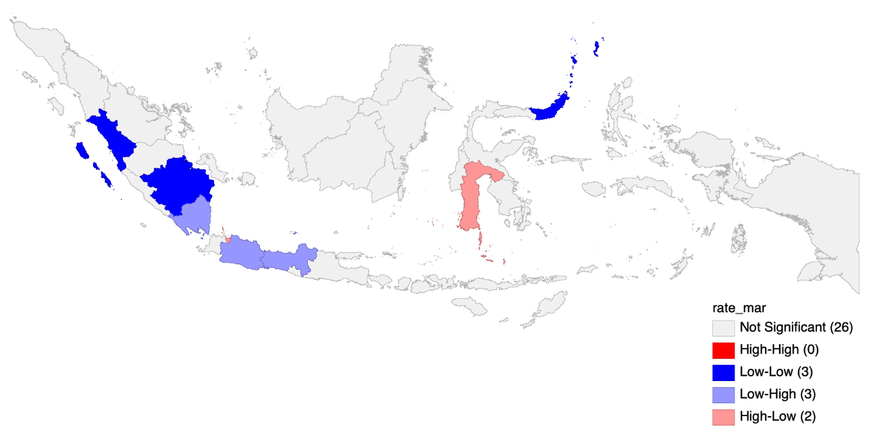
Fig. 7: Local spatial dependence in March 2020

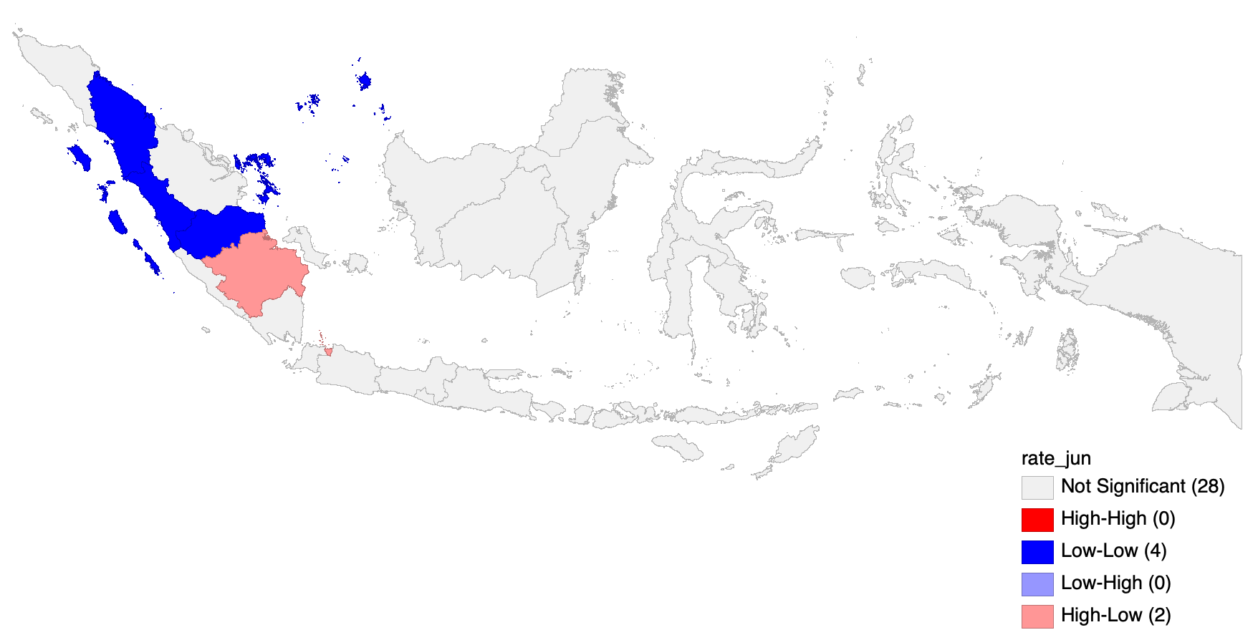
Fig. 8: Local spatial dependence in June 2020

The LISA cluster maps of the number of COVID-19 infection cases are given in Figure 7 and 8 for March and June 2020 period respectively. By the end of March - the first month of COVID-19 case detected in Indonesia - there were three provinces in low-low cluster (West Sumatra, South Sumatra and North Sulawesi), three provinces in low-high cluster (Lampung, West Java, and Central Java), two provinces in high-low cluster (Jakarta and South Sulawesi), and none of provinces in high-high cluster. The spread of COVID-19 in provinces in Sumatra island were relatively low. Meanwhile, the presence of spatial outliers of high-low cluster and low-high cluster in Java island (the most populated island) is particularly interesting. The first COVID-19 case in Indonesia was detected in Depok District, West Java province in March 2, 2020. However, during the month, the number of cases in Jakarta (the capital city and located next to West Java) rose significantly higher than that in West Java. This may reflect the two following possibilities; first, the massive COVID-19 testing in Jakarta and second, the strong connectivity between these two provinces where most of people who live in West Java work in Jakarta.
In June, however, provinces previously in low-high cluster in Java island were no longer present. This is because the increased rate of COVID-19 infection in these provinces (West Java and Central Java) during the period. Interestingly, Jakarta remained in high-high cluster, marking the capital city as the epicenter of COVID-19 cases in the country. Possibly, the missing low-high cluster in Java island reflects the contagion from Jakarta. This is particularly true during the period of Ramadan followed by Eid al-Fitr where people traveled to their home town to meet relatives. In Sumatra, an increased infection case from April to June 2020 has moved South Sumatra province from low-low to high-low cluster. Meanwhile, four provinces located near South Sumatra were in low-low cluster (North Sumatra, West Sumatra, Riau Islands and Jambi). Reflecting the transition pattern observed in Java island from March to June, it is important to anticipate the contagion from South Sumatra to neighboring provinces.
4.2 How COVID-19 pandemic affects regional growth dynamics?
This section presents the main findings of spatial autoregressive models in evaluating how the pandemic affects the spillovers of economic growth across provinces. To be more precise, we measure how the growth in a province is affected by the growth in surrounding regions. Ideally, in our equation we should consider all necessary growth determinants explained in the standard Solow growth model featuring the Cobb-Douglas production function (Islam, 1995). However, due to data availability and time constraint, we use initial economic condition (log of GDP in 2019:Q1) as the proxy of growth determinants, where the economy is assumed to be in its natural condition. Thus, our models capture the spatial effects of economic growth by controlling the natural level of main growth determinants. To understand the impacts of the pandemic, the models are estimated for two different time span; from 2019:Q1 to 2019:Q4 and from 2019:Q1 to 2020:Q2. For simplicity, the first period is called pre-pandemic period and the latter is referred to pandemic period.
One important assumption in spatial autoregressive model is the existence of spatial dependence in residuals. Thus, before estimating the spatial autoregressive model, we conducted spatial dependence test by applying Moran’s I test. Table 1 presents the results of the test between two periods; pre-pandemic period (Column 1) and pandemic period (Column 2). The result from Moran’s I test suggests to reject the hypothesis that residuals in the pandemic period are independent and identically distributed (i.i.d.). This indicates that the residual factors in the economic growth equation are spatially dependent during COVID-19 period as opposed to before pandemic period, implying the importance of including spatial variable in the model. Therefore, it is vital to formally append the inclusion of spatial weight matrix before the coefficients in the model.
Before estimating spatial regression models with spatial lag variable for pandemic period, we reconfirmed the absence of spatial dependence in regional growth dynamics in pre-pandemic period. Table 2 presents the results of spatial and non-spatial regressions of the economic growth before COVID-19 outbreak. All spatial regressions are estimated using maximum likelihood estimator for cross-sectional data. The table shows that none of coefficients in SLM and SEM models are significant, except the coefficient of OLS model. However, since the residuals are spatially correlated (as indicated by the Moran’s I test result in Table 1), using the OLS model could be inappropriate.
Now in Table 3 we present the results of spatial and non-spatial regressions of the economic growth in pandemic period, where it evaluates the effect of COVID-19 pandemic to the regional growth dynamics. All coefficients reported in Table 3 show negative sign and are statistically significant for both spatial models. Furthermore, the model selection criteria presented at bottom of the table suggests to select Spatial Error Model (SEM) as the best specification model, given the smallest AIC value.
The negative and significant coefficient on the log of GDP in 2019:Q1 implies that larger economies suffer more from growth declining due to the pandemic. Since most of provinces with high GDP are located in Java-Bali region, the slump in economic growth during pandemic period is relatively larger in this region.
As mentioned earlier, the spatial error model assumes that the error term of province i depends on the error term of neighboring provinces on the basis of spatial weight matrix. In other words, significant spatial error coefficient reported Table 3 shows that the decline in growth during the pandemic is affected by both province-specific shocks and other ‘spill-over’ shocks from neighboring provinces. Practically, the negative coefficient suggests that the increase of shocks of the neighboring regions tend to decrease the economic growth of a particular province.
Finally, as suggested by LeSage and Pace (2009), the estimated coefficient of SLM and SEM specification can be decomposed into direct and indirect effects to show the contribution of spatial spillovers. However, in the spatial error model, spatially correlated errors do not induce spillover effects in the covariates. Therefore, the results from this exercise lead to further research avenue to formally specify the ”shocks” (other variables unexplained in this study) and then measure their impacts on regional growth dynamics.

Table 3: Non-spatial and spatial regression models after COVID-19 outbreak (2019:Q1 - 2020:Q2)

Conclusion
This study aims to reveal spatial pattern of the coronavirus (COVID-19) infection across provinces in Indonesia and to investigate the impacts of the virus outbreak on regional economic growth dynamics. Our exploratory analysis exposes the link between spatial connectivity and the spread of the virus, particularly in Java region, mainly between Jakarta, West Java and Central Java, the three neighboring and closely connected provinces. From the spatial analysis, our evaluation suggests that spatial dependence in regional growth dynamics does present in pandemic period. Thus, failure to control for spatial dependence in analyzing regional growth could be inappropriate. Furthermore, the results from spatial econometric models show that the provincial growth in the pandemic period is affected by the spillover of shocks in the surrounding regions.
As common in other spatial studies, we acknowledge the limitation of this study could include two following issues. First, the specification of weight matrix using contiguity of the estimated Thiessen polygons. Since there is no a single solid method that identifies a unique weight matrix reflecting the connectivity between locations, it is useful to test the models with alternative weight matrix. Second, given the availability issue and time constraints, the data used in the models is very limited to explain the complex regional growth dynamics. Therefore, future studies should incorporate more variables, including the institutional determinants of growth at a province level to obtain reliable estimates.

References

ADB (2020). The Economic Impact of the COVID-19 Outbreak on Developing Asia. Asian Development Bank. https://www.adb.org/sites/default/files/publication/571536/adb-brief-128-conomic-impact-COVID19-developing-asia.pdf. Accessed: 2020-08-28.
Anselin, L. (1988). Spatial Econometrics: Methods and Models. Kluwer Academic Publisher, Dordrecht, Netherlands.
Anselin, L. (1995). Local indicators of spatial association—LISA. Geographical Analysis, 27(2):93–
115.
Anselin, L., Sridharan, S., and Gholston, S. (2007). Using exploratory spatial data analysis to leverage social indicator databases: The discovery of interesting patterns. Social Indicators Research, 82(2):287–309.
BBC (2020). Coronavirus: The world in lockdown in maps and charts. https://www.bbc.com/news/world-52103747. Accessed: 2020-08-25.
COVID19 projections.com (2020). COVID-19 Projections Using Machine Learning. https://COVID19-projections.com/indonesia. Accessed: 2020-08-28.
del Rio-Chanona, R. M., Mealy, P., Pichler, A., Lafond, F., and Farmer, D. (2020). Supply and demand shocks in the COVID-19 pandemic: An industry and occupation perspective. arXiv preprint arXiv:2004.06759.
Fingleton, B. (1999). Estimates of time to economic convergence: an analysis of regions of the European Union. International Regional Science Review, 22(1):5–34.
Fingleton, B. and Lopez-Bazo, E. (2006). Empirical growth models with spatial effects. ´ Papers in Regional Science, 85(2):177–198.
Guerrieri, V., Lorenzoni, G., Straub, L., and Werning, I. (2020). Macroeconomic implications of COVID-19: Can negative supply shocks cause demand shortages? Technical report, National Bureau of Economic Research.
Hausmann, R. (2020). Flattening the COVID-19 Curve in Developing Countries. Project Syndicate. https://www.project-syndicate.org/commentary/flattening-COVID19-curve-in-developing-countries-by-ricardo-hausmann-2020-03. Accessed: 2020-04-28.
IMF (2020). World Economic Outlook Update, June 2020. A Crisis Like No Other, An Uncertain Recovery. International Monetary Fund. https://www.imf.org/en/Publications/WEO/Issues/2020/06/24/WEOUpdateJune2020. Accessed: 2020-08-28.
Inoue, H. and Todo, Y. (2020). The propagation of the economic impact through supply chains: The case of a mega-city lockdown against the spread of COVID-19. Available at SSRN 3564898.
Islam, N. (1995). Growth empirics: A panel data approach. The quarterly journal of economics, 110(4):1127–1170.

LeSage, J. and Pace, K. (2009). Introduction to Spatial Econometrics. Chapman & Hall/CRC, Boca Raton, Florida.
OECD (2020). OECD Indonesia Economic Outlook No 107 - June 2020 Double Hit Scenario. Organization for Economic Co-operation and Development. https://stats.oecd.org/Index.aspx?QueryId=72657. Accessed: 2020-08-29.
Rey, S. J. and Montouri, B. D. (1999). US regional income convergence: A spatial econometric perspective. Regional Studies, 33(2):143–156.
WHO (2020a). A Statement on Novel Coronavirus in Thailand. World Health Organization. Geneva. https://www.who.int/news-room/detail/13-01-2020-who-statement-on-novel-coronavirus-in-thailand. Accessed: 2020-08-28.
WHO (2020b). Situation Report. World Health Organization. Geneva. https://www.who.int/docs/default-source/coronaviruse/situation-reports/20200131-sitrep-11-ncov.pdf?sfvrsn=de7c0f7_4. Accessed: 2020-08-25.
WHO (2020c). Situation Report. World Health Organization. Geneva. https://www.who.int/docs/default-source/coronaviruse/20200630-COVID-19-sitrep-162.pdf?sfvrsn=e00a5466_2. Accessed: 2020-08-25.
WHO (2020d). Situation Report, Indonesia. World Health Organization. Geneva. https://www.who.int/docs/default-source/searo/indonesia/COVID19/who-situation-report-14.pdf?sfvrsn=39243224_2. Accessed: 2020-08-25.

Output gap is the gap between potential and actual output. For simplicity, we used Hodrick-Prescott (HP) filter to extract the trend of GDP data as estimate of potential output. The computed output gap is the difference between actual GDP data and its estimated trend.
The data shows how people to (or time spent in) categorized places change compared to baseline days. The baseline day is the median value from the 5-week period Jan 3 – Feb 6, 2020, representing a normal value for that day of the week. For further details about category of places and everything related to the data, please visit https://support.google. com/COVID19-mobility/answer/9824897?hl=en&ref_topic=9822927.
We include the share of Transportation, Accommodation and Services (TAS) to GDP in addition to previous variables. In the statistics of Indonesian GDP, TAS sector includes ”Transportasi dan Pergudangan”, ”Penyediaan Akomodasi dan Makan Minum”, ”Administrasi Pemerintahan, Pertahanan dan Jaminan Sosial Wajib”, and ”Jasa Lainnya”.
We planned to also use unemployment data. However, the official unemployment data that capture the COVID-19 pandemic period will be released in November 2020.
”High” and ”low” are in relative term to the mean of the variable, and thus can not be interpreted as an absolute term.
According to official news from Indonesian government.

